Joe Dennis U. Mauricio

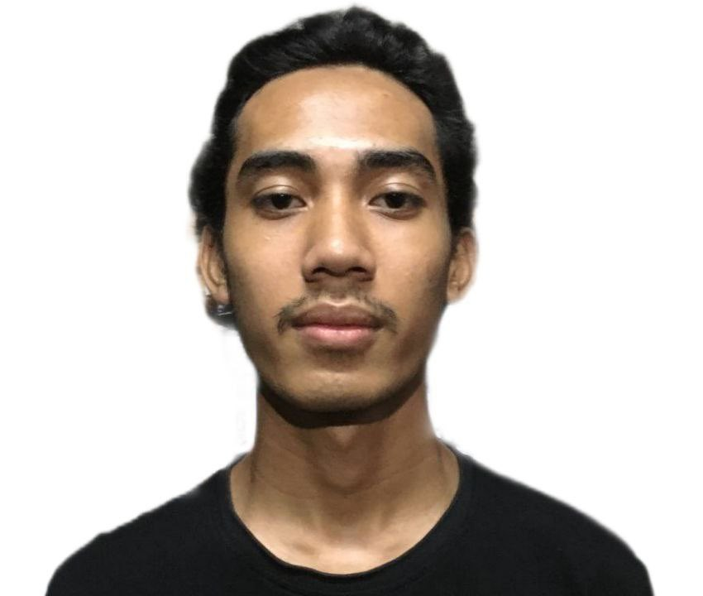
Poblacion North Ramos, Tarlac
+639-994-252-8401
jdmauricio1111@gmail.com

CAREER OBJECTIVE

Seeking an IT-related internship to apply my skills in programming and networking while contributing to innovative projects. Eager to grow professionally in a dynamic environment and gain hands-on experience that will pave the way for a successful career in the tech industry

PERSONAL INFORMATION

Date of Birth: March 08, 2002
Sex: Male
Civil Status: Single
Citizenship: Filipino

EDUCATIONAL ATTAINMENT

Bachelor’s Degree
AMA Computer College - Tarlac, 2020 - Current
San Roque Tarlac City, Tarlac
Thesis Title: Air Quality Monitoring using Isolation Forest with GIS

Secondary
CIT Colleges, 2014-2019
Burgos Street. Poblacion Norte Paniqui, Tarlac

CERTIFICATION

Introduction to Cybersecurity (11 Dec 2023)
Cybersecurity Essentials (6 Mar 2024)
CCNAv7: Introduction to Networks (13 Apr 2023)
CCNAv7: Switching, Routing, and Wireless Essentials (21 Aug 2023)

